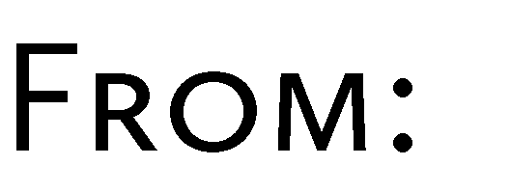
By signing this form, I hereby authorize Zest Cuisine to charge my company/personal credit card listed below. Please fill in all the requested information and check all boxes that apply. Cancellation with less than 72 hours will incur a charge of 100%.
PLEASE EMAIL BACK TO: Marie@ZestCuisineToYou.com
     |  |     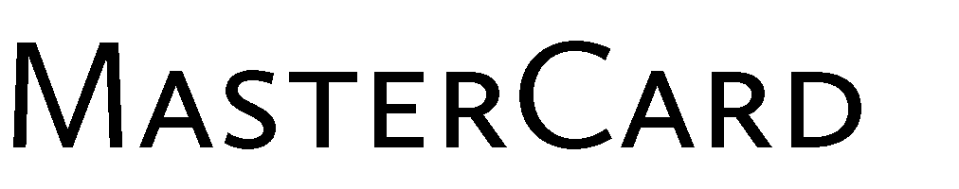 |  |     
 | 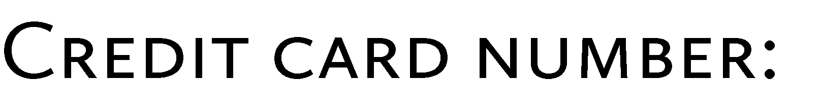
 | 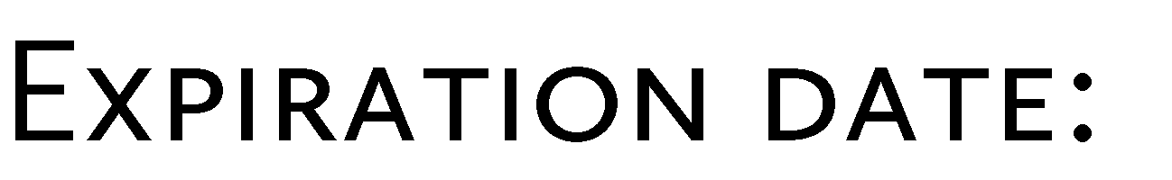
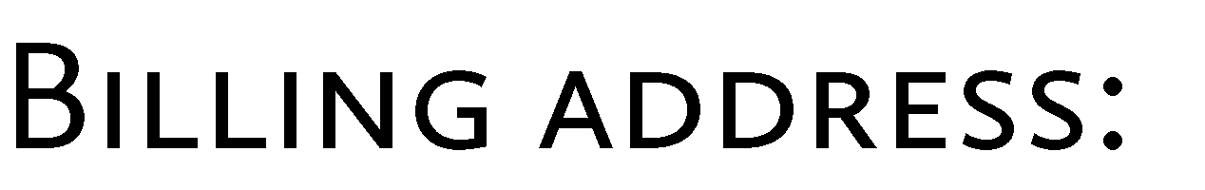
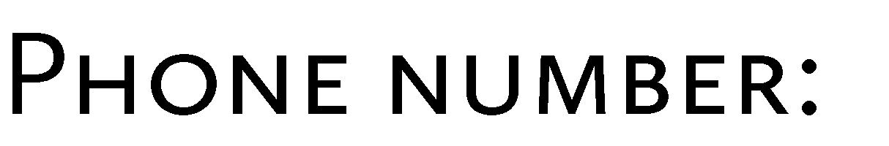

ZESTCUISINE
Catering
1316 Ponderosa Drive - Petaluma, California 94954
T: 707-755-1405 - www.ZestCuisineToYou.com

